

| Name of Student | Shimpei Pshikiri | ID | 70359 |
| --- | --- | --- | --- |

**Assessment 2 – Research (Online)**



Contents

Instructions: 1

Duration: 1

Multiple-choice Questions: 2

Please put your learning notes here: 7

Project management basic 7

Project management History 7

Project management in the future 7

Document Search Index 8

## Instructions:

This is an individual assessment. Answer all the questions on the document provided by your Trainer.

## Duration:

Trainer will set the duration of the assessment.

## Multiple-choice Questions:

1. What advice do we give about factoring in the commitments of project stakeholders when making your own plans? 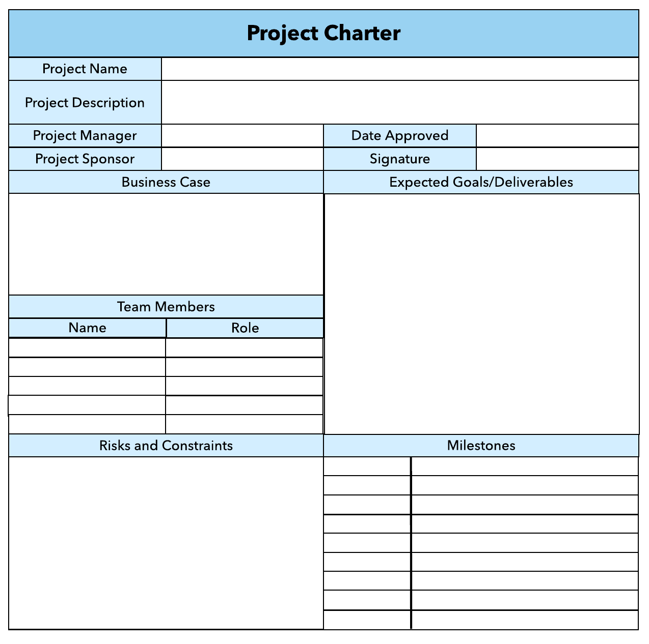
   1. Consult student timetables to see when they might be free to attend data collection sessions.
   2. Ask external organizations what the most convenient times would be for you to visit
   3. Neither of these

d) Both A and B

Comment: your plan needs your stakeholders know before implantation.

1. Which of the following are essential components of a GANTT chart used to plan your project?
   1. Your home telephone number
   2. Your supervisor’s home telephone number
   3. The email address for the chair of the ethics committee
   4. None of the above

Comment: in order to get right or good Gantt Char, you need keep concern time, cost, scope and quality. So will get the good requirement and write good Gantt Char.

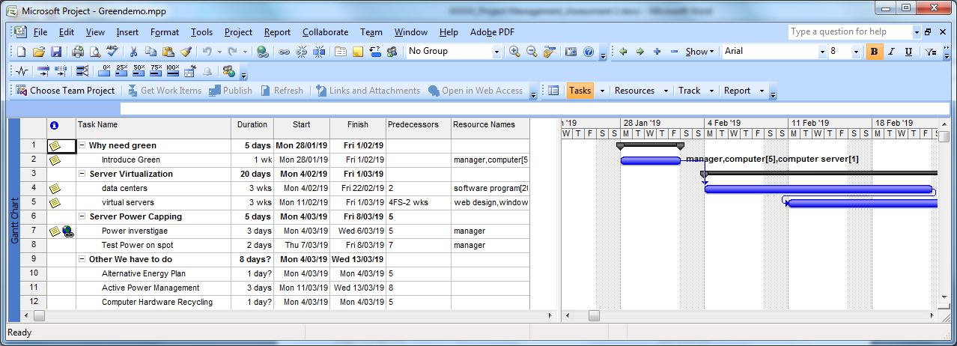

1. The intended outcome of strategy/projects integration is
   1. Clear organization focus
   2. Best use of scarce organization resources
   3. Improved communication across projects and departments
   4. Both A and C are correct
   5. A, B, and C are all correct

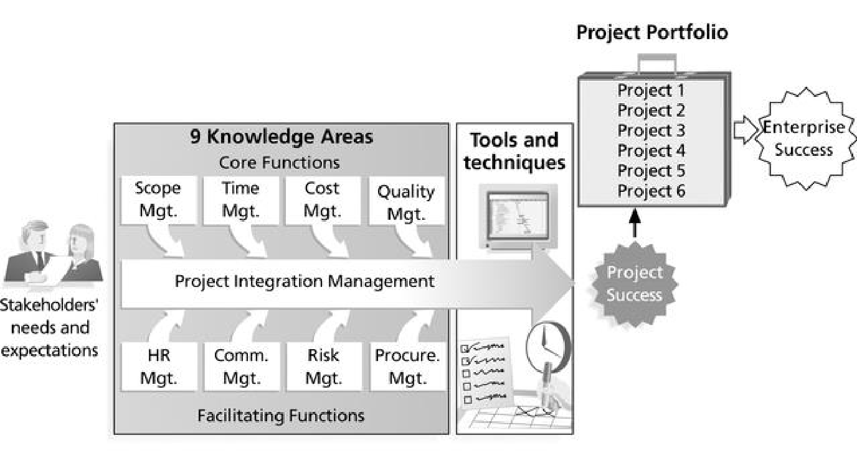

Comment: **Integration** management is a collection of processes required to ensure that the various elements of the **projects** are properly coordinated. It involves making trade-offs among competing objectives and alternatives to meet or exceed stakeholder needs and expectations.

Web Refer: <https://en.m.wikibooks.org/wiki/Project_Management/PMBOK/Integration_Management>

1. Which of the following questions does the organization's mission statement answer?
   1. What are our long-term strategies?
   2. What are our long-term goals and objectives?
   3. How do we operate in the existing environment?
   4. What do we want to become?
   5. All of these are answered by the mission statement 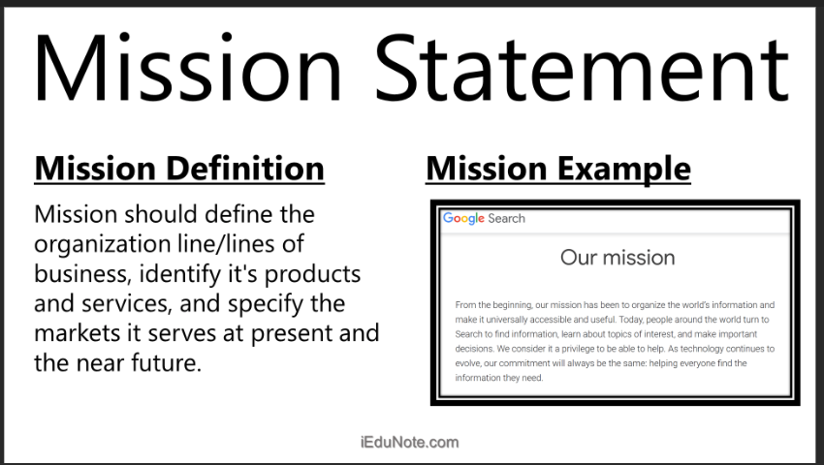

1. Which of the following is not one of the requirements for successful implementation of strategies through projects?
   1. Allocation of resources
   2. Prioritizing of projects
   3. Motivation of project contributors
   4. Adequate planning and control systems
   5. All of these are requirements

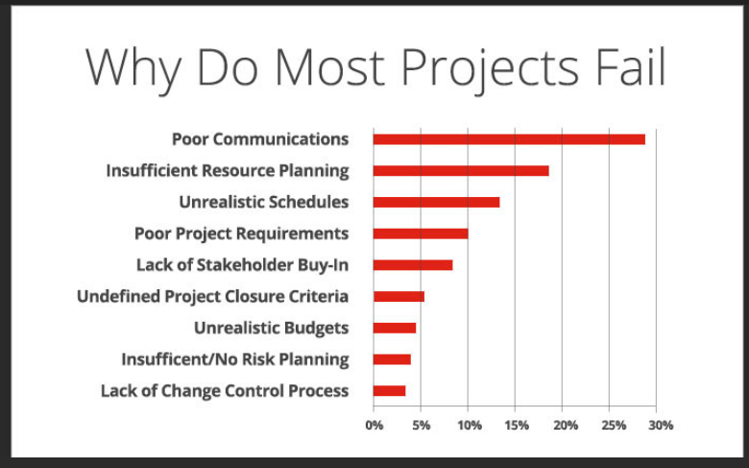

everythings is needed for a project, especially communication.

1. Which of the following is the reason(s) why project managers need to understand their organization's mission and strategy?
   1. To make appropriate decisions and adjustments
   2. To be effective project advocates
   3. To be able to get their job done
   4. Both A and B are correct
   5. A, B, and C are all correct

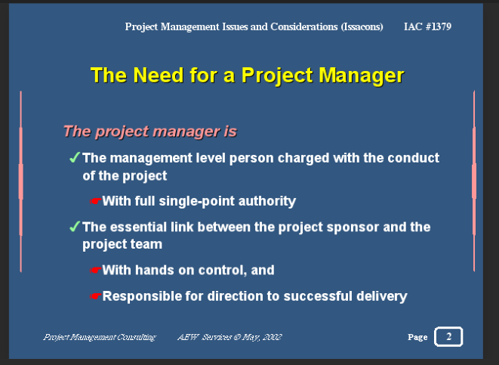

Project manager must be a well-known person in a project to lead and control them to the mission.

Understanding missions and strategy helps a manager to manage a team.

1. Which of these is the highest priority and first strategy required for any organizational change?

a) Communication

* 1. Stress management
  2. Negotiation
  3. Learning
  4. Employee involvement

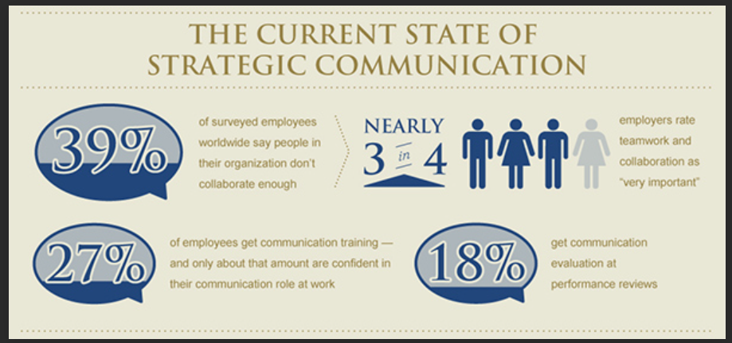

There are so many people who have complained to their company because of poor communication.

1. Which of the following is not a procedure to obtain an understanding risk in the planning stage (described in ISA 315):
   1. Inquiries of management
   2. Analytical procedures
   3. Observation and inspection
   4. Procedures for sampling audit tests

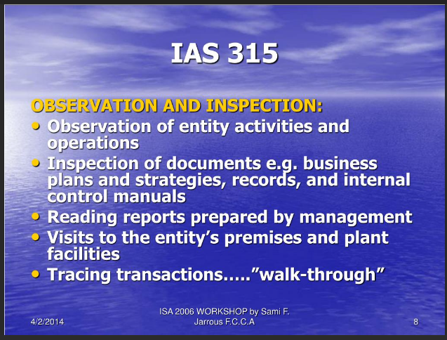

1. Assessment of control risk includes three steps. Which of the following is not one of these steps?
   1. Obtaining an understanding of internal controls and documentation of the controls
   2. Evaluate sufficiency and appropriateness of audit evidence
   3. An initial assessment and response to assessed risk based on the design of internal controls resulting in an audit planning memorandum and audit plan
   4. A final assessment based upon test of controls of operating effectiveness

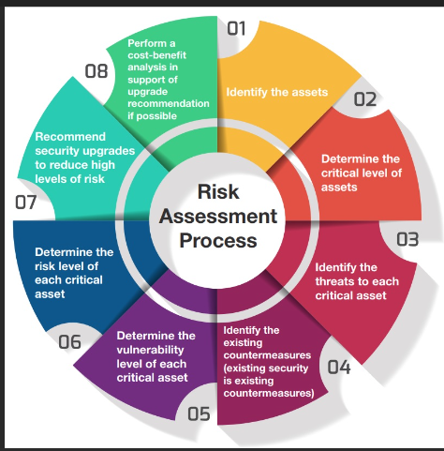

“c” is the definition. No2-No7 in the picture, these are “a”. No8 is “d”

1. Which of the following are not common internal control documentation techniques used by auditors?

a) Questionnaires

* 1. Company internal control manuals
  2. Narrative descriptions
  3. Check lists

Auditor's report is typically based on “Generally accepted auditing standards (GAAS)” . A Report usually consists of 3 paragraphs.

refer : [Generally Accepted Auditing Standards: Definition, GAAS vs. GAAP (investopedia.com)](https://www.investopedia.com/terms/g/gaas.asp)

1. Overall response to assessed risk may include:
   1. Identify the absence of key controls (where controls are lacking)
   2. Identify existing controls
   3. Incorporating additional elements of unpredictability in the selection of further audit procedures to be performed
   4. Determine potential material misstatements that could result

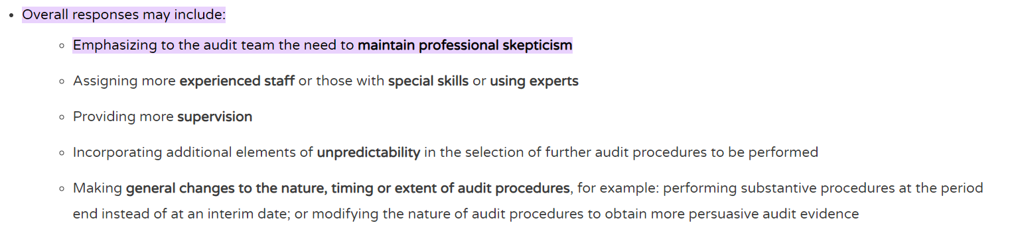

refer : [CAS 330 The Auditor's Responses to Assessed Risks - HTK Academy](https://htkacademy.com/cas-330-the-auditors-responses-to-assessed-risks/#:~:text=The%20auditor%20shall%20design%20and%20implement%20overall%20responses,audit%20team%20the%20need%20to%20maintain%20professional%20skepticism)

1. Action plan Should be 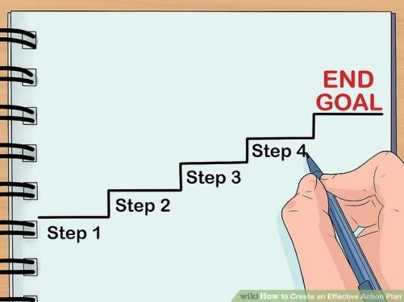
   1. Specific
   2. Countable
   3. Realistic
   4. Achievable

Comment: An **action plan** is a detailed **plan** outlining actions needed to reach one or more goals. Alternatively, businessdictionary.com defines an **action plan** as a "sequence of steps that must be taken, or activities that must be performed well, for a strategy to succeed".

Web Refer: <https://en.wikipedia.org/wiki/Action_plan>

1. Which of the following is not a function of Project Management Tool? 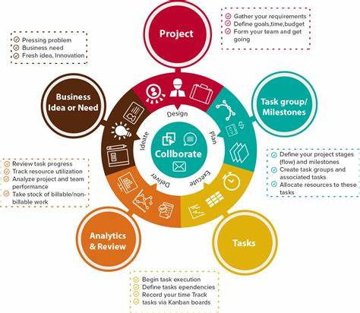
   1. Plan a project
   2. Manage Tasks
   3. Manage Issues
   4. Time Tracking
   5. Non of above

You can manage a project time to finish it in due

date. It is important thing.

However, Time tracing is not respectable for your

team.

1. John, the project manager for the ERP Project, is about to complete the project phase review. The completion of a project phase is also known as which of the following?
2. A lesson learned
   1. A kill point
   2. Earned value management
   3. Conditional advancement

The project conclusion describes the successful achievement of the project goal. It includes the final phases of a project: product acceptance, a final analysis, experience assurance and the final project resolution. These points are summarized in the project conclusion report. Only when all activities related to the project have been completed, the project is finished. If the actual goal has not been achieved, this is called a project termination.

refer: [Definition: Project completion | projectfacts](https://www.projectfacts.com/glossary/project-completion.html#:~:text=Project%20completion%20The%20project%20conclusion%20describes%20the%20successful,analysis%2C%20experience%20assurance%20and%20the%20final%20project%20resolution.)

1. Which of the following is not a key stakeholder in a project that creates a service internal to an organization?
   1. The project manager
   2. External customers
   3. Project vendors
   4. Project team members



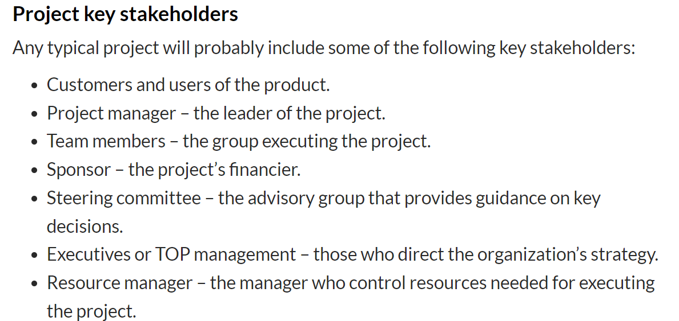

refer: [What Is a Stakeholder in Project Management? | Hygger.io](https://hygger.io/blog/stakeholder-project-management/#stakeholders-and-the-key-project-stakeholders-what-is-the-difference)

You do not have to consider external customers. This is unpredictable and not the main thing.

1. Managing a project is best described as which one of the following?
   1. Establishing direction
   2. Functional controls over the project team and stakeholders
   3. Consistently producing key results expected by stakeholders
   4. Motivating and inspiring the project team to produce results that are expected by project stakeholders

A project produces value for its stakeholders, clients, and community. For a project manager to ensure this, they need to understand the client’s industry,strategy,business ,and organization as a whole.

1. You are the project manager for your organization. Influencing your organization requires which of the following?
   1. An understanding of the organizational budget
   2. Research and documentation of proven business cases
   3. An understanding of formal and informal organizational structures
   4. Positional power

Organizational structure is not only required by the organization, but also helps define who’s in charge,group employees more efficiently, and define responsibilities.

There are several types of organizational structures.

refer:[8 Types of Project Management Organizational Structures | Indeed.com](https://www.indeed.com/career-advice/career-development/project-management-organizational-structures)

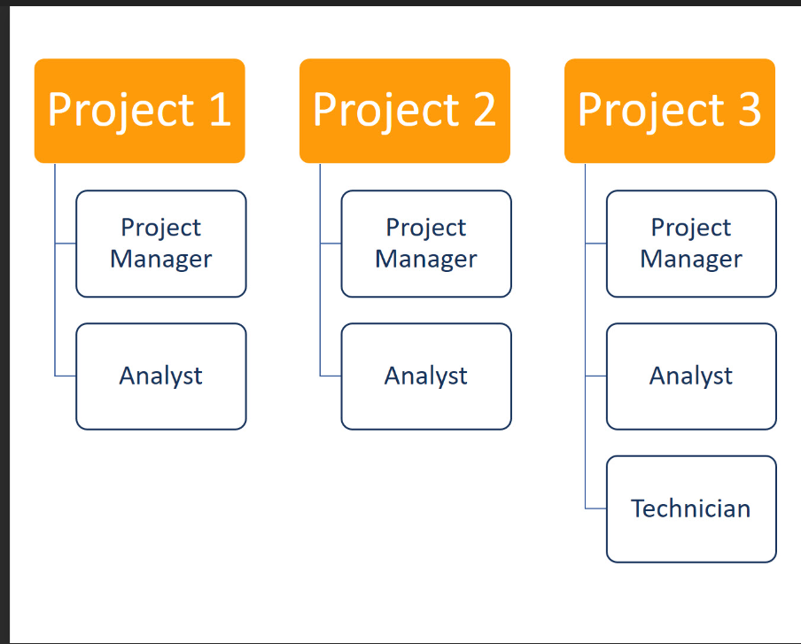

1. What is the difference between a standard and a regulation?
   1. Standards are mandatory; regulations are not.
   2. Standards are optional; regulations are not.
   3. Regulations and standards are essentially the same.
   4. Regulations are usually mandatory; standards may be seen as guidelines.

“ As nouns the difference between standard and regulation is that standard is a principle or example or measure used for comparison while regulation is (uncountable) the act of regulating or the condition of being regulated.

As adjectives the difference between standard and regulation is that standard is falling within an accepted range of size, amount, power, quality, etc while regulation is in conformity with applicable rules and regulations.”

refer:[Standard vs Regulation - What's the difference? | WikiDiff](https://wikidiff.com/regulation/standard#:~:text=As%20nouns%20the%20difference%20between%20standard%20and%20regulation,As%20adjectives%20the%20difference%20between%20standard%20and%20regulation)

1. Which of the following is an example of a deliverable at the end of the requirements-gathering phase in a software design project?
   1. Responsibility matrix creation
   2. Detail design document
   3. Business needs
   4. Project team assembled

The key deliverables in software design project are

・Brainstorming session

・Mood boards and element collages

・Dynamic prototypes and the end product

refer:[Key Deliverables to Include in Your Software Design Phase | Synapse Software](https://synapsesoftware.com/blog/danny-castillo/key-deliverables-include-your-software-design-phase)

1. At what point in a project would a kill point be acceptable?
   1. When a project team member is not performing as planned
   2. When a project reaches the end of a project phase
   3. When a project reaches the end of its budget
   4. When a project manager determines the project team cannot continue

By breaking projects down into phases, management can make sure that their projects are still compatible with the changing needs of the organization.

refer:[What you need to know about killing a project (mpug.com)](https://www.mpug.com/killing-a-project/)

1. Of the following, which is not an exit criterion?
   1. Customer sign-offs
   2. Quality metrics
   3. Stakeholder analysis
   4. Regulatory inspections

Exit criterion is used to determine whether a given test activity has been completed or NOT. Exit criteria can be defined for all of the test activities right from planning, specification and execution.

Example

・Verify if All tests planned have been run.

・Verify if the level of requirement coverage has been met.

・Verify if there are NO Critical or high severity defects that are left outstanding.

・Verify if all high risk areas are completely tested.

・Verify if software development activities are completed within the projected cost.

・Verify if software development activities are completed within the projected timelines.

refer:[Exit Criteria (tutorialspoint.com)](https://www.tutorialspoint.com/software_testing_dictionary/exit_criteria.htm#)

1. At which point is the risk of failure the least but the consequence of failure the highest?

a) During the early stages

* 1. During the middle stages
  2. During the final stages
  3. Risk of failure is even across all project phases

The final task of this phase is to review the entire project complete a detailed report that covers every aspect. All of the necessary data is stored in a secure place that can be accessed by project managers of that organization.

Risk is determined as an event that may impact to the final outcomes or to the final objectives of the project

1. In project estimation, project manager has to provide an expert judgement, which are considered of the following EXCEPT:
   1. Impact of inflation over the project lifecycle
   2. Required labour and labour rates
   3. Material costs and assumptions
   4. Costs of quality
   5. All of above
   6. None of above

In project estimation techniques, you can construct a ballpark estimate that roughly aligns the three main project contractions: cost,scope and time.

1. Which component is/are included in Quality Management Plan
   1. Quality objectives
   2. Key project deliverables
   3. Quality standards
   4. Quality control and assurance activities
   5. All of above

***Quality Management*** *is the act of overseeing all activities and tasks that must be accomplished to maintain a desired level of excellence. This includes the determination of a quality policy, creating and implementing quality planning and assurance, and quality control and quality improvement.*

refer:[Quality Management Plan (QMP) - AcqNotes](https://acqnotes.com/acqnote/careerfields/quality-management-plan-qmp#:~:text=4%20Steps%20of%20a%20Quality%20Management%20Plan%20%28QMP%29,Step%204%3A%20Take%20Corrective%20Action%20if%20Necessary%20)

1. What's an activity sequencing
   1. The process for identifying and documenting dependencies among schedule activities 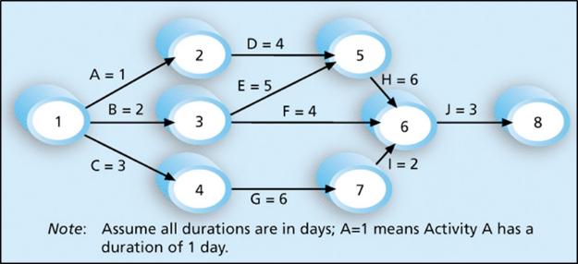
   2. The process for identifying critical activities
   3. The process for identifying ordering and schedule activities
   4. The process for planning the project

***Activity sequencing*** reviews all activities in the WBS with the goal of identifying relationships between them and classifying all the timing relationships among tasks. These relationships (aka "linkages", "dependencies", "predecessors"). Task timing relationships are important because they control task sequencing and task start and end dates. There are four types of task relationships:  
A ***finish-to-start relationship***

A ***start-to-start relationship***

A ***finish-to-finish relationship***

A***start-to-finish relationship***

Refer: <https://www.e-education.psu.edu/geog871/l5_p4.html>

Comment: activity sequencing could help make your project stage very clear and easy to follow the project progress. The process for identifying and documenting dependencies among schedule activities

<https://www.youtube.com/watch?v=rBSCvPYGnTc&t=1323s>

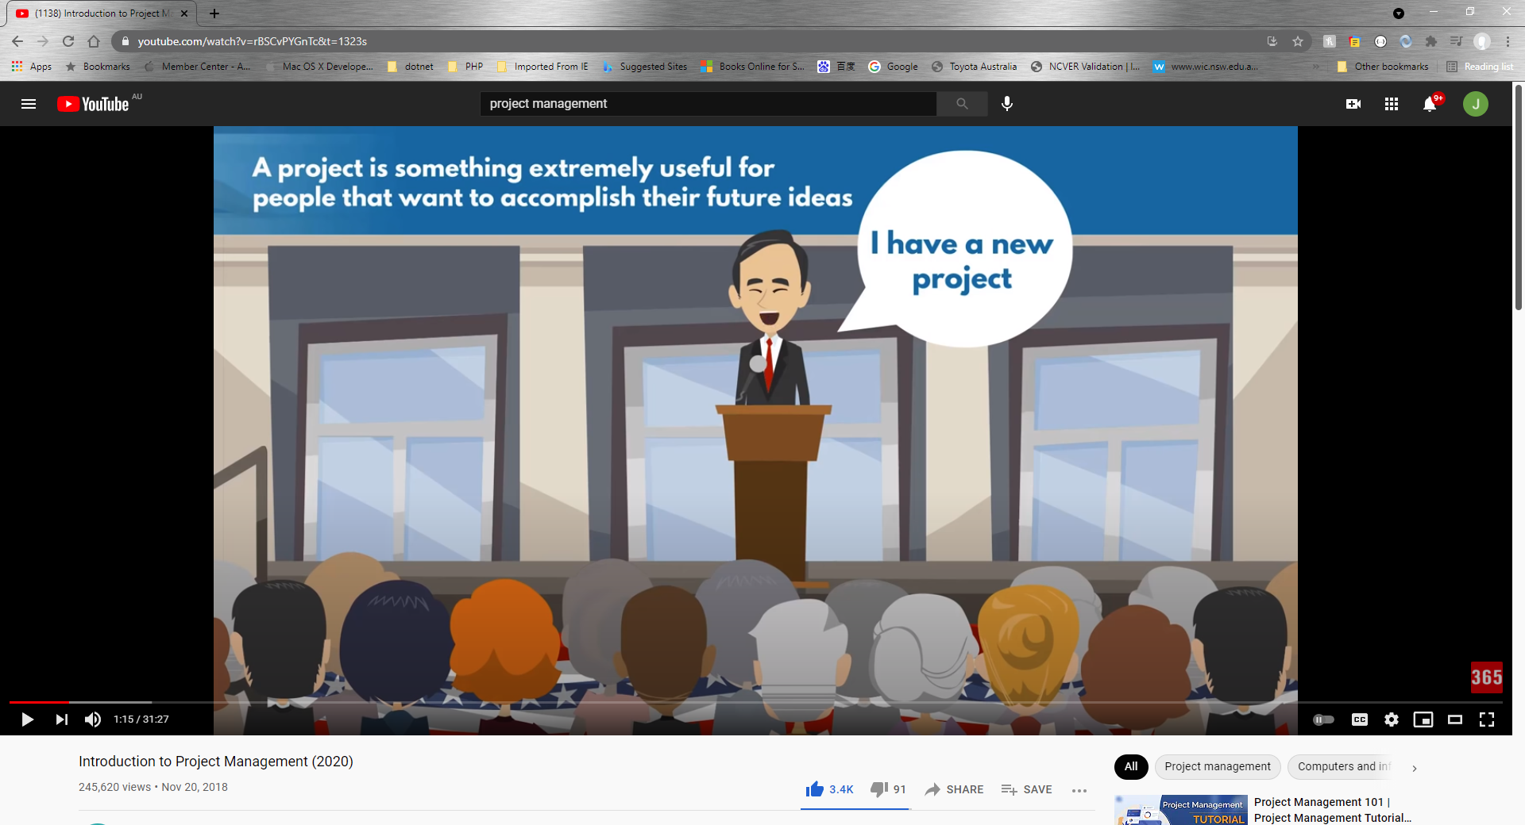

## Please put your learning notes here:

## Project management basic

PMO =The department responsible for managing, coordinating and consulting project-related work

In the PMO, you can find project and program managers, project coordinators , and analysis, engineers, construction workers, and more.

The scale of PMO depends on how big the project is. Companies do not have to launch PMO if a project is small .

Stakeholders are people who could influence the project work, even without being involved in the project itself, such as consultant, customers, other organizations, project manager, project team.

## Project management History

20 Century the Henry Gantt first make Gantt Chart Diagram. It is the revolution to know more about project management.

## Project management in the future

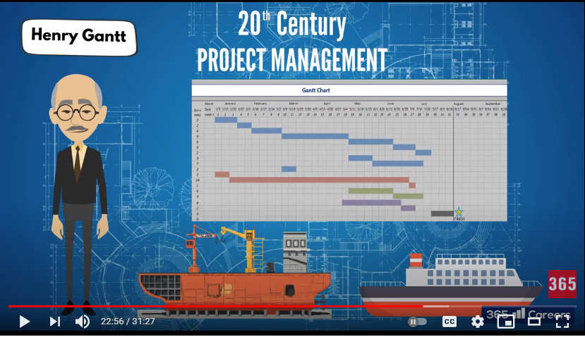

## Document Search Index

**A**

a GANTT chart 2

**M**

mission and strategy 3

mission statement 3

**O**

organizational change 3

**P**

project stakeholders 2

projects integration 2

**S**

successful implementation 3

**U**

understanding risk 4